Question 27:
Create a JSP program to count the number of clients viewed on your website.

Program:
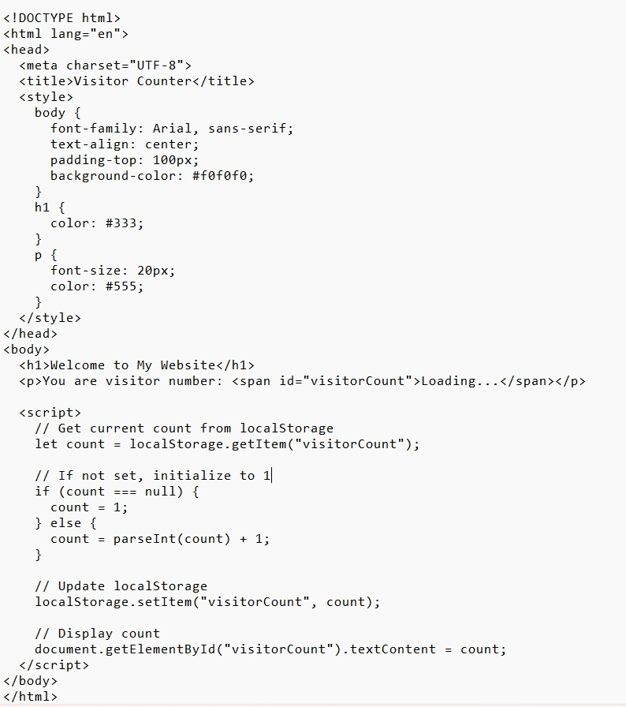

Output:
